## **LONG-RANGE WIRELESS STARTER KIT**

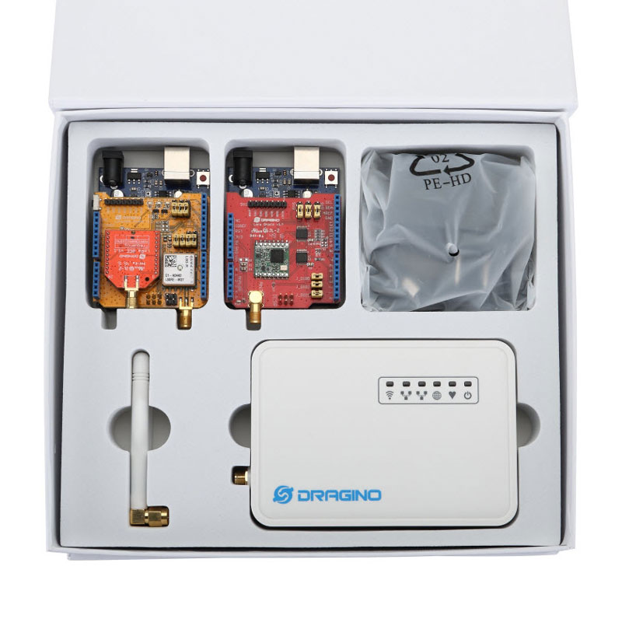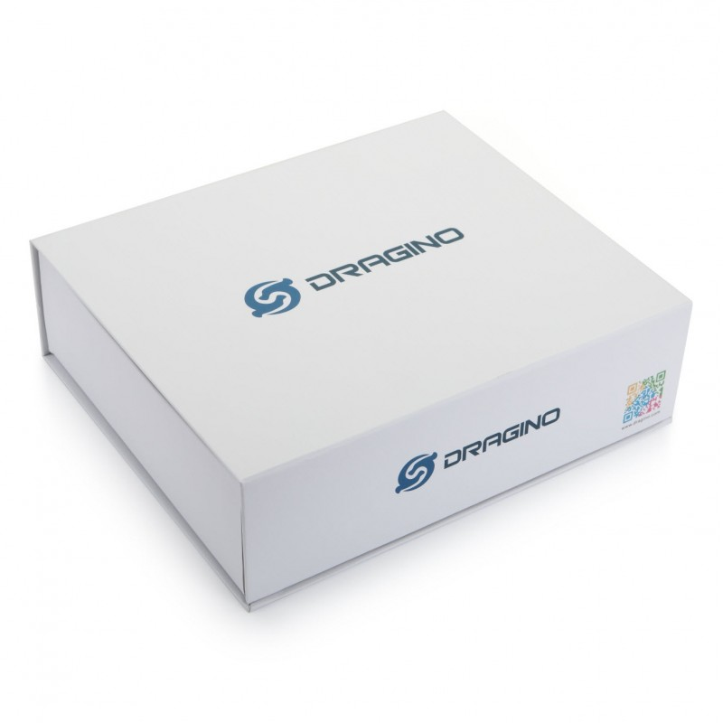

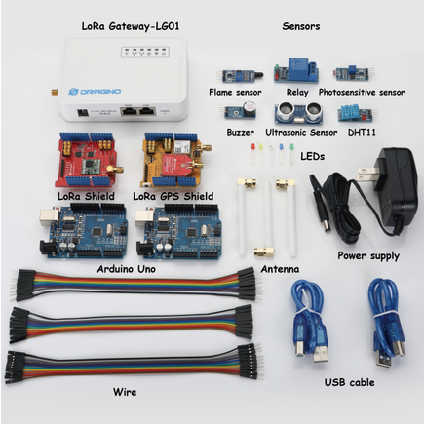**Specifications**

**Long-range wireless starter Kit is pack of**

* 1 x Single Channel LoRa Gateway
* 1 x (LoRa Shield + Arduino UNO)
* 1 x (LoRa/GPS Shield + Arduino UNO)
* 1 x flame sensor
* 1 x Relay
* 1 x photosensitive sensor
* 1 x Buzzer
* 1 x Ultrosonic Sensor
* 1 x DHT11 Temperature and Humidity Sensor
* 20 x dupont wire (male to male)
* 20 x dupont wire (female to female)
* 20 x dupont wire (female to male)

**Single Channel LoRa Gateway**

* Processor: 400MHz, 24K MIPS
* Flash: 16MB ; RAM: 64MB
* MCU: ATMega328P
* 10M/100M RJ45 Ports x 2
* WiFi : 802.11 b/g/n
* LoRa Wireless
* Power Input: 12V DC
* USB 2.0 host connector x 1
* USB 2.0 host internal interface x 1
* 1 x LoRa Interface
* Open Source OpenWrt system
* Low power consumption
* Firmware upgrade via Web
* Software upgradable via network
* Flexible protocol to connect to IoT servers
* Auto-Provisioning
* Built-in web server
* Managed by Web GUI, SSH via LAN or WiFi
* Internet connection via LAN, WiFi and USB
* Failsafe design provides robustly system
* 1 x SX1276/SX1278 LoRa module
* Limited support in LoRaWAN/ Support Private LoRa protocol
* Support upto 300 nodes
* LoRa band available at 865-867 MHz
* Max range in LoRa: 3~10 km
* Up to 14.4Mbps downlink and 5.76Mbps uplink data rates
* Bullet-proof front end: IIP3 = -12.5 dBm.
* Excellent blocking immunity.

**LoRa Shield**

* 168 dB maximum link budget.
* +20 dBm - 100 mW constant RF output vs.
* +14 dBm high efficiency PA.
* Programmable bit rate up to 300 kbps.
* High sensitivity: down to -148 dBm.
* Bullet-proof front end: IIP3 = -12.5 dBm.
* Excellent blocking immunity.
* Low RX current of 10.3 mA, 200 nA register retention.
* Fully integrated synthesizer with a resolution of 61Hz.
* FSK, GFSK, MSK, GMSK, LoRaTM and OOK modulation.
* Built-in bit synchronizer for clock recovery.
* Preamble detection.
* 127 dB Dynamic Range RSSI.
* Automatic RF Sense and CAD with ultra-fast AFC.
* Packet engine up to 256 bytes with CRC.
* External Antenna via I-Pex connector

**LoRa GPS Shield**

* LoRa Shield basic Spec mentioned above along with following GPS Spec
* Power Acquisition: 25mA, Power Tracking: 20mA.
* Compliant with GPS, SBAS.
* Programmable bit rate up to 300 kbps.
* Serial Interfaces UART: Adjustable 4800~115200 bps, Default: 9600bps.
* Update rate: 1Hz (Default), up to10Hz.
* Protocols: NMEA 0183, PMTK.
* Horizontal Position Accuracy: Autonomous <2.5 m CEP.
* TTFF@-130dBm with EASY™: Cold Start <15s, Warm Start <5s,Hot start <1s;TTFF@-130dBm.
* Without EASY™: Cold Start <35s, Warm Start <30s,Hot Start <1s.
* Timing Accuracy: 1PPS out 10ns，Reacquisition Time <1s.
* Velocity Accuracy Without aid <0.1m/s, Acceleration Accuracy Without aid 0.1m/s².
* Sensitivity Acquisition -148dBm，Tracking -165dBm，Reacquisition -160dBm.
* Dynamic Performance Altitude Max.18000m，Maximum Velocity Max.515m/s, Maximum Acceleration 4G.
* L1 Band Receiver (1575.42MHz) Channel 22 (Tracking) /66 (Acquisition).